Request for Qualifications (RFQ) for Engineering/Architectural/Surveying Services - Cover Letter

3/11/2022

Re: American Rescue Plan Act (ARP Act)

Dear Architectural Service Providers:

Attached is a copy of the County’s Request for Qualifications (“RFQ”) for architectural services. These services are being solicited to assist Leon County in its project related services and project implementation of a contract, if awarded from the ARP Act program(s). Leon County is considering applying for such funding to support activities in the County.

Multiple contracts may be awarded as a result of this solicitation.

The submission requirements for this SOQ are also included on the attached Request for Qualifications (RFQ) form. Please submit a Statement of Qualifications (“SOQ”) to:

Debbie Reeder
113 W Main 2nd Floor, P.O. Box 898, Centerville Texas
Email to: Debbie.reeder@co.leon.tx.us

The deadline for submission of SOQs is 5:00PM on March 21, 2022. It is the responsibility of the submitting entity to ensure that the SOQ is received in a timely manner. SOQs received after the deadline will not be considered for award, regardless of whether or not the delay was outside the control of the submitting provider. Leon County reserves the right to negotiate with any and all service providers submitting timely SOQs.

Leon County is an Affirmative Action/Equal Opportunity Employer. Section 3 Residents, Minority Business Enterprises, Small Business Enterprises, Women Business Enterprises, and Labor Surplus Area firms are encouraged to submit SOQs.

Sincerely,

Debbie Reeder
RFQ for Engineering/Architectural/Surveying Services

The County is seeking to enter into an architectural services contract with an architect licensed in the state of Texas. The following outlines this request for qualifications.

- Scope of Work

A sample detailed Scope of Work provided by ARP Act engineering services is enclosed in this packet. The [engineering/architectural/surveyor] contract will encompass all preparation and project related architectural services to the County under its ARP Act program project(s). See detailed Scope of Work beginning on page 6:

- Statement of Qualifications - The County is seeking to contract with an experienced engineering/architectural/surveying firm, licensed to practice in the State of Texas. Respondent to provide detailed information as outlined below:
- Public works design/construction including, but not limited to mitigation projects, county jails, justice centers, and/or county courthouses.
- Federally funded construction projects; and
- Provide a listing of any/all projects located in this general region of the state
- Transmittal letter including:
  - Brief statement of the firm’s understanding of the scope of the work to be performed;
  - Confirmation that the firm meets the appropriate state licensing requirements to practice as an Architect/Engineer in Texas
  - Confirmation that the respondent firm has not been accused of providing defective design(s) with in the last five (5) years; if it has, please provide a listing and explanation of each;
  - Confirmation that the respondent firm has not been accused of fraud or deceptive trade practices within the last five (5) years;
  - Any other information that the firm feels appropriate to support their understanding;
- Company Profile
- Experience and Qualifications. Set forth your experience and qualifications as they relate to the proposed project in terms of technical scope, tasks involved, deliverable products, and other elements of the work as they relate to the evaluation criteria and all requirements of this RFQ including the following:
  - Experience with public works construction including but not limited to mitigation projects;
  - Experience with federally funded construction projects;
  - A list of past local government clients, as well as resumes of all engineers/architects/surveyors that will or may be assigned to this project if you receive the engineering/architectural/surveying services contract award.
- SAM.gov Registration. Firms must have an active registration with the System for Award Management (www.SAM.gov) AND have been cleared (not suspended or debarred). Provide proof of SAM.gov registration along with your Statement of Qualifications. See next page.
- References. Each firm must furnish a minimum of five (5) references.

- Evaluation Criteria - The SOQ received will be evaluated and ranked according to the following criteria and using the rating sheet enclosed:

 | Criteria |  | Maximum Points
 | Experience |  | 60
 | Work Performance |  | 25
 | Capacity to Perform |  | 15
 | Total |  | 100

- For this RFQ, Respondent’s qualifications will be evaluated and the most qualified Respondent will be selected, subject to negotiation of fair and reasonable compensation.
- Upon the award of this contract, profit (either %/actual cost) must be identified and negotiated as a separate element of the price for any contract in excess of $50,000.00.

- Submission Requirements- the following documents must be included in your SOQ:
- A copy of your current certificate of insurance, including all coverages for professional liability. State if your policy is an eroding policy.
- Statement of Conflicts of Interest (if any) the service provider or key employees may have regarding these services, and a plan for mitigating the conflict(s). Note that County may in its sole discretion determine whether or not a conflict disqualifies a firm, and/or whether or not a conflict mitigation plan is acceptable.
- System for Award Management. Service Providers must have an active registration in the System for Award Management (https://www.sam.gov/SAM/). Service provider and its Principals may not be debarred or suspended nor otherwise on the Excluded Parties List System (EPLS) in the System for Award Management (SAM). Include verification that the service provider as well as its principals are not listed (are not debarred) through the System for Award Management (www.SAM.gov). Enclose a printout of the search results that includes the record date. This clearance information should be included in the service provider’s SOQ. The clearance in the Service Provider’s SOQ must be re-verified prior to award. Federal awarding agencies may relax the timing of the requirement for active SAM registration at time of allocation in order to expeditiously issue funding. At the time of award, the requirements of 2 CFR § 200.206, Federal awarding agency review of risk posed by recipients, continue to apply. Current registrants in SAM with active registrations expiring between April 1, 2021 and September 30, 2021 will automatically be afforded a one-time extension of 180 days. (2 CFR § 25.110).
- Form Conflict of Interest Questionnaire, (enclosed). Texas Local Government Code chapter 176 requires that any vendor or person who enters or seeks to enter into a contract with a local government entity disclose in the Questionnaire Form CIQ the vendor or person’s employment, affiliation, business relationship, family relationship or provision of gifts that might cause a conflict of interest with a local government entity. Questionnaire form CIQ is included in the RFQ and must be submitted with the response.
- Certification Regarding Lobbying- Disclosure of Lobbying Activities (enclosed). Certification for Contracts, Grants, Loans, and Cooperative Agreements is included in the RFQ and must be submitted with the response.
- Form 1295, (enclosed). Effective January 1,2018, all contracts and contract amendments, extensions, or renewals executed by the Commissioners Court will require the completion of Form 1295 “Certificate of Interested Parties” pursuant to Government Code § 2252.908. Form 1295 must be completed by the awarded vendor at time of signed contract submission. Form 1295 is included in this RFQ for your information. Form 1295 requires the inclusion of an “unsworn declaration” which includes, among other things, the date of birth and address of the authorized representative signing the form.
- Required Contract Provisions (enclosed). Applicable provisions (enclosed) must be included in all contracts executed as a result of this RFQ.

- Contracting with small and minority businesses, women's business enterprises, and labor surplus area firms. – Small and minority businesses, women's business enterprises, and labor surplus area firms must participate in this RFQ. If the awarded vendor is a prime contractor and may use subcontractors, the following affirmative steps are required of the prime contractor:
- Placing qualified small and minority businesses and women's business enterprises on solicitation lists;
- Assuring that small and minority businesses, and women's business enterprises are solicited whenever they are potential sources;
- Dividing total requirements, when economically feasible, into smaller tasks or quantities to permit maximum participation by small and minority businesses, and women's business enterprises;
- Establishing delivery schedules, where the requirement permits, which encourage participation by small and minority businesses, and women's business enterprises;
- Using the services and assistance, as appropriate, of such organizations as the Small Business Administration and the Minority Business Development Agency of the Department of Commerce.
- Please choose the MBDA Center that is in closest proximity to your community. Please use the following link: https://www.mbda.gov/mbda-programs. Email your RFP to the appropriate center. If your Center cannot be reached by email, it is strongly recommended that the RFP be sent to the appropriate center via CERTIFIED MAIL, return receipt requested.

Minority-owned businesses may be eligible for contract procurement assistance with public and private sector entities from MBDA centers:

Dallas MBDA Business Center | Houston MBDA Business Center
8828 N. Stemmons Freeway, Ste. 550B | 3100 Main Street, Ste. 701
Dallas, TX 75247 | Houston, TX 77002
214-920-2436 | 713-718-8974
Website: https://www.mbdadfw.com  Email: admin1@mbdadallas.com | Website: https://www.mbda.gov/business-center/houston-mbda-business-center
 | Email: MBDA@hccs.edu
El Paso MBDA Business Center | San Antonio MBDA Business Center
2401 East Missouri Avenue | 501 W. Cesar E. Chavez Blvd., Ste. 3.324B
El Paso, TX 79903 | San Antonio, TX 78207
915-351-6232 | 210-458-2480
Website: https://www.mbda.gov/business-center/el-paso-mbda-business-center | Website: https://www.mbda.gov/business-center/san-antonio-mbda-business-center
Email: treed@ephcc.org | Email: orestes.hubbard@utsa.edu
Small and woman-owned businesses may be eligible for assistance from SBA Women’s Business Centers:

U.S. Small Business Administration- Dallas/Fort Worth District Office | WBEA – Women’s Business Center
150 Westpark Way, Ste. 130 | 9800 Northwest Freeway, Ste. 120
Euless, TX 76040 | Houston, TX 77092
214-572-9452 | 713-681-9232
Website: https://www.sba.gov/offices/district/tx/dallas-fort-worth | Website: https://www.wbea-texas.org/womens-business-center
Email: dfwdo.email@sba.gov | Email: wbc@wbea-texas.org
LiftFund Women’s Business Center
600 Soledad St.
San Antonio, TX 78205
888-215-2373 ext. 3000
Website: https://womensbusinesscentersa.com/
Email: wbc@liftfund.com

SBA also provides assistance at Small Business Development Centers located across Texas:
https://americassbdc.org/small-business-consulting-and-training/find-your-sbdc/

- Deadline for Submission – SOQs must be received no later than 5:00PM on March 21, 2022. It is the responsibility of the submitting entity to ensure that the SOQ is received in a timely manner. SOQs received after the deadline will not be considered for award, regardless of whether or not the delay was outside the control of the submitting firm.
Complete the Public Notice information in the instructions - Please electronically submit your SOQ in .pdf format via email at debbie.reeder@co.leon.tx.us OR submit 3 copies of your proposal of services and a statement of qualifications for the proposed services to the following address: Attn: Debbie Reeder, Assistant Auditor, 113 W Main, 2nd Floor, P.O. Box 898, Centerville, Texas 75833. Statements of Qualifications must be received by the County no later than 5:00PM on March 21, 2022, to be considered.

Any questions or requests for clarification must be submitted in writing via EMAIL to the address above at least 3 business days prior to the deadline. County may, if appropriate, circulate the question and answer to all service providers who submitted an SOQ.
AMERICAN RESCUE PLAN ACT (ARP ACT) - Description of Programs

Below is a description of anticipated programs that are eligible for funding through the ARP Act Program funded through the U.S. Department of the Treasury or other designated State or Federal Agency. As currently defined by U.S. Treasury guidance, selected Projects must use the allocated funds in one of the following ways. The City/County anticipates selecting a respondent for the following programs that require Engineering Services:

(A) to respond to the public health emergency with respect to the Coronavirus Disease 2019 (COVID–19) or its negative economic impacts, including assistance to households, small businesses, and nonprofits, or aid to impacted industries such as tourism, travel, and hospitality;

(B) to respond to workers performing essential work during the COVID–19 public health emergency by providing premium pay to eligible workers of the metropolitan city, non-entitlement unit of local government, or county that are performing such essential work, or by providing grants to eligible employers that have eligible workers who perform essential work;

(C) for the provision of government services to the extent of the reduction in revenue of such metropolitan city, non-entitlement unit of local government, or county due to the COVID–19 public health emergency relative to revenues collected in the most recent full fiscal year of the metropolitan city, non-entitlement unit of local government, or county prior to the emergency; or

(D) to make necessary investments in water, sewer, or broadband infrastructure.

Applicant: ___________________________________________________
ARP Act

APPROVED BY:

County Judge Byron Ryder

SCOPE OF WORK

The Contractor shall provide the following scope of services:

SCOPE OF SERVICES REQUESTED
Providers will help the County fulfill State and Federal ARP Act statutory responsibilities related to recovery from COVID-19. Providers will assist the County in completion of ARP Act program(s). Respondents may be qualified to provide Program Engineering services for one or more programs or services (environmental, acquisition, general administration, etc.) Program engineering services must be performed in compliance with the guidance provided by the US Treasury.

DESCRIPTION OF SERVICES AND SPECIAL CONDITIONS
Respondents must be able to perform the tasks listed herein to be considered eligible for an award under this Solicitation. Respondents should provide a detailed narrative of their experience as it relates to each of the items below. Respondents should clearly indicate if they intend to provide services in-house with existing staff or through subcontracting or partnership arrangements. Engineering Services will be provided in conformance with the guidance documents utilizing forms provided by the US Treasury or other designated agencies, if applicable. The Providers shall furnish pre-funding and post-funding program engineering services to complete the ARP Act projects, including, but not limited to the following:
General Requirements

- Coordinate, as necessary, between subrecipient and its service providers (i.e., Engineer, Environmental, Contracted Construction Company, Grant Administrator, etc.) and ARP Act regarding project design services.
- Provide monthly project status updates.
- Funding release will be based on deliverables identified in the contract.

Initial Engineering and Design Support
Respondents will be required to show the ability to provide all the Engineering services described below:

- Assist with the development of project related services, including, but not limited to cost estimates, preparation of project justification, project maps and accurate project descriptions.
- Provide all project information necessary to ensure timely execution of the environmental review (if required).
- Provide preliminary engineering, investigations, and drawings sufficient to achieve the preliminary design milestone, including at a minimum:
  - Cross sections/elevations
  - Project layout/staging areas
  - General notes
  - Special notes
  - Design details
  - Specifications
  - Utility relocation designs
  - Construction limits, including environmentally sensitive areas that should be avoided during construction
  - Required permits
  - Quantities
  - Estimate of construction costs to within +/- 25%
  - Schedules for design, permitting, acquisition and construction
- Design surveying, topographic and utility mapping.
- Perform subsurface explorations for project sites, as necessary.
- Prepare horizontal alignments/layouts for all proposed project alternatives necessary to fully describe the project scope, anticipated limitations, and potential project impacts.
- Recommend value engineering options (alternative design, construction methods, procurement, etc.) that may improve efficiency, expedite the schedule, or reduce project costs for the subrecipient.
- Identify, acquire and submit all necessary permits and approvals required for design approval and construction.
- Submit all necessary deliverables to the appropriate entity for review and comment. Adjust project and/or design to satisfactorily address any comments, as necessary.
- Prepare plans and profiles, including vertical design information for the selected alternative.
- Identify and address potential obstacles to project implementation (i.e., pipelines, easements, permitting, environmental, etc.) prior to moving forward with the final design.
- Support subrecipient with acquisition or property/servitudes/right-of-way documentation as required by the City to facilitate the project, preparing right-of-way surveys and/or property boundary maps and legal descriptions of parcels to be acquired.
- Provide project schedules from cradle to grave in MS Project format or equal as approved by the subrecipient based on ARP Act guidance.

Engineering and Final Design Support
Respondents will be required to show the ability to provide all the Engineering services described below as they relate to final design support:
- Prepare plans and profiles, including necessary design information for the selected alternative sufficient to achieve all detailed design milestones. Examples include, but are not limited to:
  - Cross sections/elevations
  - Project layout/staging areas
  - General notes
  - Special notes
  - Design details
  - Specifications
  - Utility relocation designs
  - Construction limits, including environmentally sensitive areas that should be avoided during construction
  - Required permits
  - Quantities
  - Estimate of construction costs to within +/- 20%
  - Schedules for design, permitting, acquisition and construction
- Provide information to appropriate individuals for the development of environmental fund release reports and floodplain maps.
- Identify, acquire and submit all necessary permits and approvals required for design approval and construction.
- Provide hard copy, if necessary, reproducible plan drawings and bid documents, in addition to electronic copies to the subrecipient, upon design completion, and as requested during design. Electronic copies should be in the native format (AutoCAD DWG) along with PDF packages and should contain all corresponding references, databases, or files associated with the completed design documents.
- Assist the subrecipient and any service provider related to the project with all necessary documentation to ensure compliance with all Program requirements and regulations.

Bid and Award Support
Respondents will be required to show the ability to provide all the Engineering services described below as they relate to bid and award support.
- Submit appropriate items and support subrecipient in the development of complete bid package.
- Prepare and assist subrecipient in the advertisements for bid solicitation.
- Support development and issuance of bid-related documents necessary to complete bid process (e.g., bid proposal form, bid addenda and supporting documentation).
- Attend and support subrecipient at pre-bid conference and bid opening.
- Support subrecipient with ongoing communication during bid process.
- Support subrecipient to complete bid tabulation and evaluation of responses and provide recommendation for award.
- Support subrecipient to negotiate and finalize contract documents, including issuance of the Notice to Proceed, in accordance with program and subrecipient requirements.
- Support subrecipient in the conducting of a preconstruction conference.

Contract Management and Construction Oversight
Respondents will be required to show the ability to provide all the Engineering services described below as they relate to contract management and construction oversight.
- Ensure delivery of subrecipient project in accordance with contract.
- Provide ongoing Construction Oversight Reports detailing the status of construction for subrecipient project.
- Review all service provider submittals to ensure compliance with construction contract documents and provide recommendations to subrecipient.
- Provide periodic and final inspections and tests reports, as required for the project.
- Provide on-site supervision and oversight of construction activities at a minimum on a bi-weekly basis or as directed by the ARP Act or subrecipient.
- Review Construction Change Orders and provide recommendation to subrecipient as to appropriate action.
- Review invoice/draw requests and provide recommendation to subrecipient as to appropriate action, in compliance with the construction contract documents.
- Obtain independent cost estimates for validation purposes, as required.
- Review and respond to requests for information/clarification.
- Support subrecipient with issue identification and claims resolutions.
- Enter all requisite information into the ARP Act system of record in accordance with established policies and procedures.
- Develop a final “as built” report of quantities, drawings, and specifications.
- Issue to the subrecipient, for execution, a Certificate of Construction Completion within 30 days of final inspection approval.
- Deliver “as-built” drawings to the subrecipient within 30 days of project completion.
- Host and/or attend project coordination meetings in person, by phone, or by video conference, which may or may not fall during normal business hours.
- Perform other contract management and construction oversight duties as required to ensure success of the subrecipient project.
- Provide necessary certifications to regulatory agencies of project completion and compliance (ex. TCEQ).
- Submit all final invoices within 60 days after contract or work order expiration.

Specialized Services
Respondents will be required to show the ability to provide all the Engineering services described below as they relate to specialized services.
- Provide Geotechnical Investigations as may be required for a project.
- Provide Detailed Surveying as may be required for a project.
- Provide Site Specific Testing as may be required for a project.
- Provide Archeological Studies as may be required for a project.
- Provide Planning Studies as may be required for a project.
- Provide Feasibility Studies as may be required for a project.
- Provide Legal documentation for property and/or easements to be acquired (i.e., field notes, etc.).
- Provide Phase I and Phase II environmental site assessments as requested.

Engineer/Architect/Surveyor Rating Sheet

Grant Recipient _______ Program(s) ARP Act
Name of Respondent __
Evaluator's Name _______ Date of Rating __________
Rate the Respondent of the Request For Qualifications (RFQ) by awarding points up to the maximum listed for each factor. Information necessary to assess the Respondent on these criteria may be gathered either from past experience with the Respondent and/or by contacting past/current clients of the Respondent. Respondents proposing to offer specific services (environmental or buyout only) will be scored only on those services.
Experience -- Rate the respondent for experience in the following areas: Comments
 | Factor | Max.Pts. |  | Score
1. | Has previously designed ___________ type of projects | 20
2. | Has worked on federally funded construction projects | 15
3. | Has worked on projects that were located in this general region.  Note: Location for A/E (Architect/Engineer) may be a selection criterion provided its application leaves an appropriate number of qualified firms, given the nature and size of the project, to compete for the contract. 2 CFR 200.321(b)(3) | 10
4. | Extent of experience in project construction management | 15
 | Subtotal, Experience | 60

Work Performance
 | Factor | Max.Pts. |  | Score
1. | Past projects completed on schedule | 10
2. | Manages projects within budgetary constraints | 5
3. | Work product is of high quality | 10
 | Subtotal, Performance | 25

Capacity to Perform
 | Factor | Max.Pts. |  | Score
1. | Staff Level / Experience of Staff | 5
2. | Adequacy of Resources | 5
3. | Professional liability insurance is in force | 5
 | Subtotal, Capacity to Perform | 15

TOTAL SCORE
 | Factor | Max.Pts. |  | Score
◻ | Experience | 60
◻ | Work Performance | 25
◻ | Capacity to Perform | 15
 | Total Score | 100

Insert Certificate of Insurance

Insert System for Award Management (SAM) record search for company name and company principal
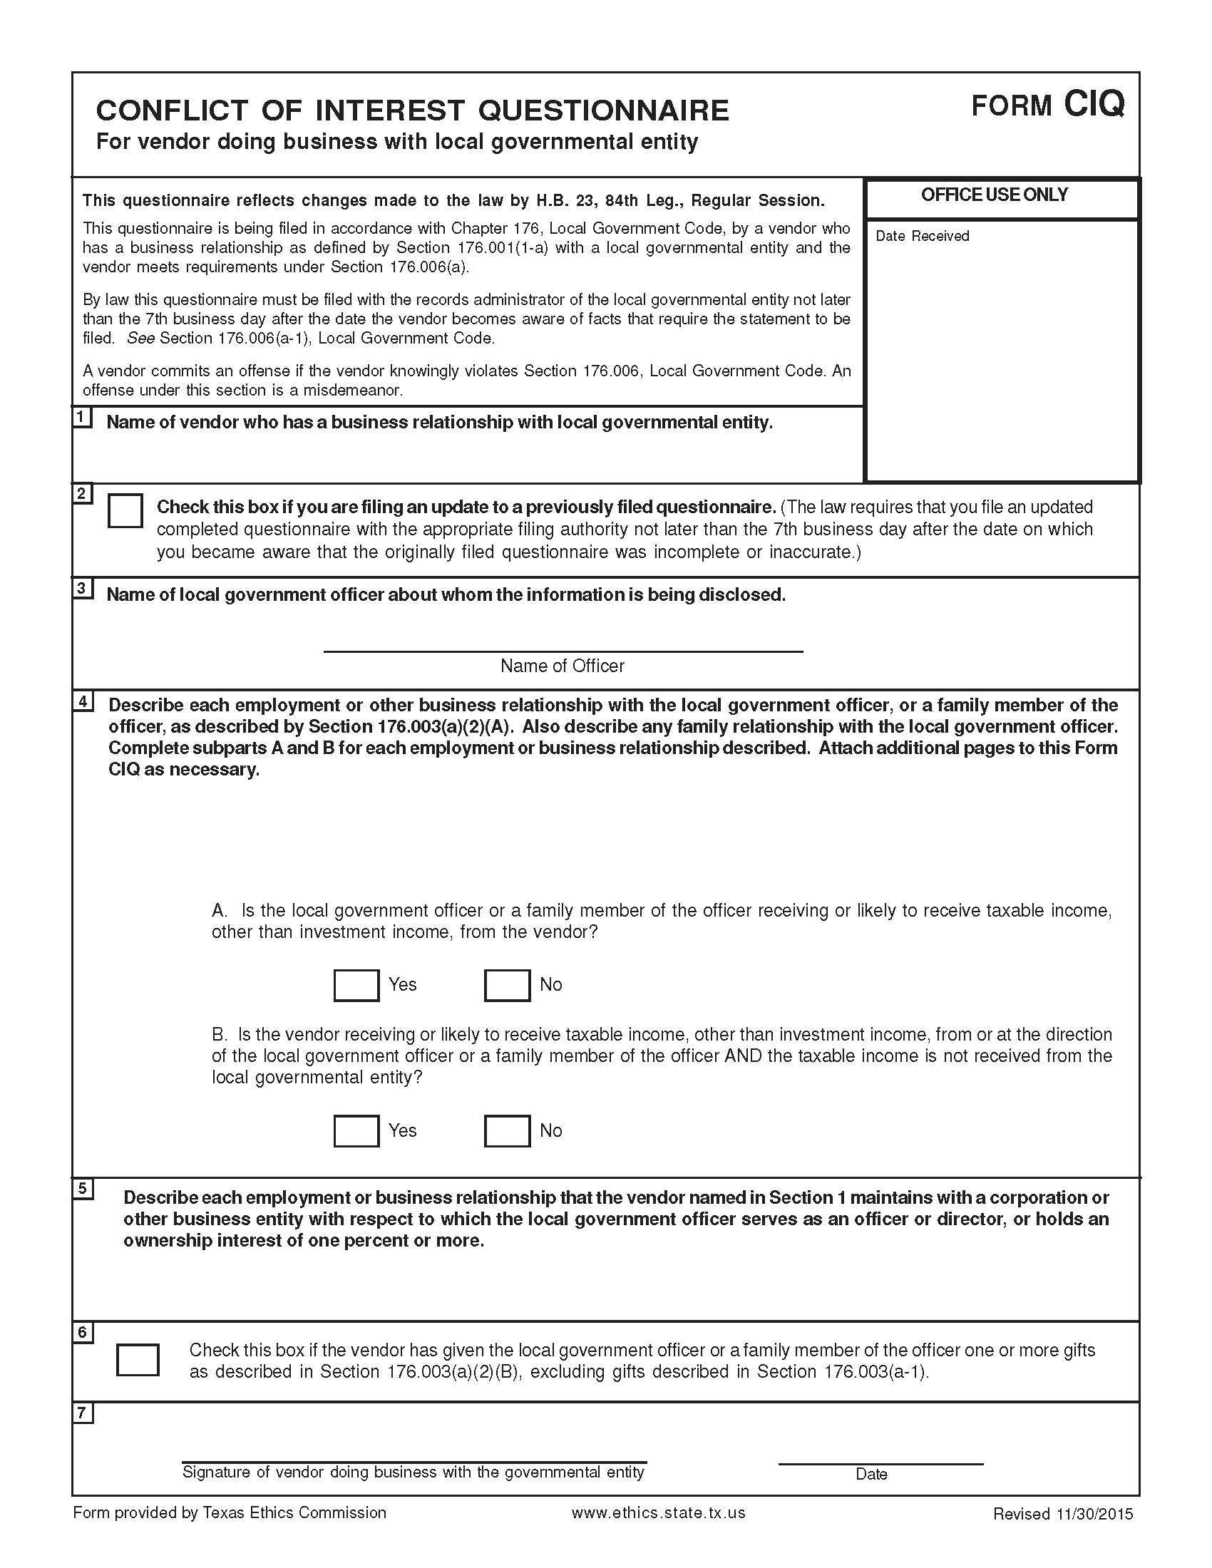
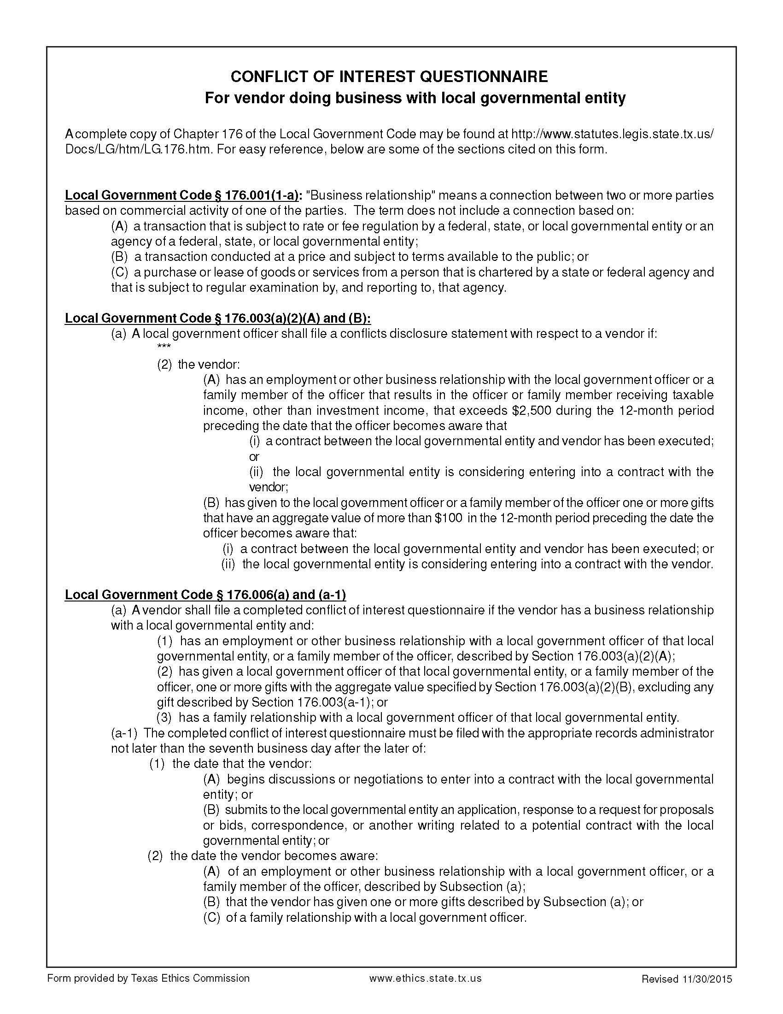
Certification Regarding Lobbying

(To be submitted with each bid or offer exceeding $100,000)

The undersigned certifies, to the best of his or her knowledge and belief, that:

(a) No Federal appropriated funds have been paid or will be paid, by or on behalf of the undersigned, to any person for influencing or attempting to influence an officer or employee of an agency, a Member of Congress, an officer or employee of Congress, or an employee of a Member of Congress in connection with the awarding of any Federal contract, the making of any Federal grant, the making of any Federal loan, the entering into of any cooperative agreement, and the extension, continuation, renewal, amendment, or modification of any Federal contract, grant, loan, or cooperative agreement.

(b) If any funds other than Federal appropriated funds have been paid or will be paid to any person for influencing or attempting to influence an officer or employee of any agency, a Member of Congress, an officer or employee of Congress, or an employee of a Member of Congress in connection with this Federal contract, grant, loan, or cooperative agreement, the undersigned shall complete and submit Standard Form-LLL, “Disclosure Form to Report Lobbying,” in accordance with its instructions.

(c) The undersigned shall require that the language paragraph 1 and 2 of this anti-lobbying certification be included in the award documents for all subawards at all tiers (including subcontracts, subgrants, and contracts under grants, loans, and cooperative agreements) and that all subrecipients shall certify and disclose accordingly.

This certification is a material representation of fact upon which reliance was placed when this transaction was made or entered into. Submission of this certification is a prerequisite for making or entering into this transaction imposed by 31, U.S.C. § 1352 (as amended by the Lobbying Disclosure Act of 1995).

The Contractor, ___________________, certifies or affirms the truthfulness and accuracy of each statement of its certification and disclosure, if any. In addition, the Contractor understands and agrees that the provisions of 31 U.S.C. § 3801 et seq., apply to this certification and disclosure, if any.

_____________________________________
Signature of Contractor’s Authorized Official

________________________________________________
Printed Name and Title of Contractor’s Authorized Official

_____________________________________
Date
INSTRUCTIONS FOR COMPLETION OF SF-LLL, DISCLOSURE OF LOBBYING ACTIVITIES

This disclosure form shall be completed by the reporting entity, whether subawardee or prime Federal recipient, at the initiation or receipt of a covered Federal action, or a material change to a previous filing, pursuant to title 31 U.S.C. section 1352. The filing of a form is required for each payment or agreement to make payment to any lobbying entity for influencing or attempting to influence an officer or employee of any agency, a Member of Congress, an officer or employee of Congress, or an employee of a Member of Congress in connection with a covered Federal action. Complete all items that apply for both the initial filing and material change report. Refer to the implementing guidance published by the Office of Management and Budget for additional information.

1. Identify the type of covered Federal action for which lobbying activity is and/or has been secured to influence the outcome of a covered Federal action.

2. Identify the status of the covered Federal action.

3. Identify the appropriate classification of this report. If this is a follow-up report caused by a material change to the information previously reported, enter the year and quarter in which the change occurred. Enter the date of the last previously submitted report by this reporting entity for this covered Federal action.

4. Enter the full name, address, city, State and zip code of the reporting entity. Include Congressional District, if known. Check the appropriate classification of the reporting entity that designates if it is, or expects to be, a prime or subaward recipient. Identify the tier of the subawardee, e.g., the first subawardee of the prime is the 1st tier. Subawards include but are not limited to subcontracts, subgrants and contract awards under grants.

5. If the organization filing the report in item 4 checks “Subawardee,” then enter the full name, address, city, State and zip code of the prime Federal recipient. Include Congressional District, if known.

6. Enter the name of the federal agency making the award or loan commitment. Include at least one organizational level below agency name, if known. For example, Department of Transportation, United States Coast Guard.

7. Enter the Federal program name or description for the covered Federal action (item 1). If known, enter the full Catalog of Federal Domestic Assistance (CFDA) number for grants, cooperative agreements, loans, and loan commitments.

8. Enter the most appropriate Federal identifying number available for the Federal action identified in item 1 (e.g., Request for Proposal (RFQ) number; Invitations for Bid (IFB) number; grant announcement number; the contract, grant, or loan award number; the application/proposal control number assigned by the Federal agency). Included prefixes, e.g., “RFQ-DE-90-001.”

9. For a covered Federal action where there has been an award or loan commitment by the Federal agency, enter the Federal amount of the award/loan commitment for the prime entity identified in item 4 or 5.

10. (a) Enter the full name, address, city, State and zip code of the lobbying registrant under the Lobbying Disclosure Act of 1995 engaged by the reporting entity identified in item 4 to influence the covered Federal action.

(b) Enter the full names of the individual(s) performing services, and include full address if different from 10(a). Enter Last Name, First Name, and Middle Initial (MI).

11. The certifying official shall sign and date the form, print his/her name, title, and telephone number.

According to the Paperwork Reduction Act, as amended, no persons are required to respond to a collection of information unless it displays a valid OMB control Number. The valid OMB control number for this information collection is OMB No. 0348-0046. Public reporting burden for this collection of information is estimated to average 10 minutes per response, including time for reviewing instructions, searching existing data sources, gathering and maintaining the data needed, and completing and reviewing the collection of information. Send comments regarding the burden estimate or any other aspect of this collection of information, including suggestions for reducing this burden, to the Office of Management and Budget, Paperwork Reduction Project (0348-0046), Washington, DC 20503
Approved by OMB
0348-0046
Disclosure of Lobbying Activities
Complete this form to disclose lobbying activities pursuant to 31 U.S.C. 1352
(See reverse for public burden disclosure)
Type of Federal Action:  a. contract  ____ b. grant  c. cooperative agreement  d. loan  e. loan guarantee  f. loan insurance | Status of Federal Action:  a. bid/offer/application  _____ b. initial award  c. post-award |  | Report Type:  a. initial filing  _____ b. material change
Name and Address of Reporting Entity:  ____ Prime _____ Subawardee  Tier______, if Known:  Congressional District, if known: |  | If Reporting Entity in No. 4 is Subawardee, Enter Name and Address of Prime:  Congressional District, if known:
Federal Department/Agency: |  | 7. Federal Program Name/Description:  CFDA Number, if applicable: __________________
Federal Action Number, if known: |  | 9. Award Amount, if known:  $
10. a. Name and Address of Lobbying Registrant  (if individual, last name, first name, MI): |  | b. Individuals Performing Services (including address if different from No. 10a)  (last name, first name, MI):
11. Information requested through this form is authorized by title 31 U.S.C. section 1352. This disclosure of lobbying activities is a material representation of fact upon which reliance was placed by the tier above when this transaction was made or entered into. This disclosure is required pursuant to 31 U.S.C. 1352. This information will be reported to the Congress semi-annually and will be available for public inspection. Any person who fails to file the required disclosure shall be subject to a civil penalty of not less than $10,000 and not more than $100,000 for each such failure. |  | Signature: __________________________________  Print Name: _____  Title: _____  Telephone No.: ____________ Date: _______
Federal Use Only |  | Authorized for Local Reproduction  Standard Form - LLL (Rev. 7-97)
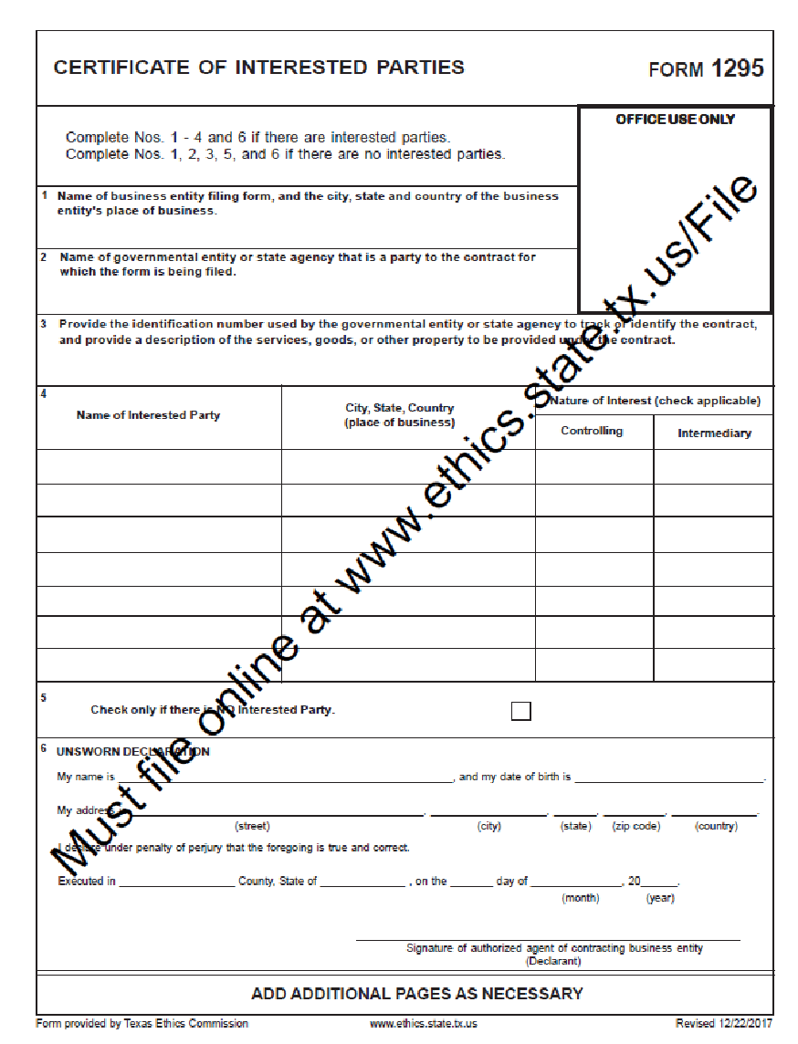
(To be completed by awarded vendor)
REQUIRED CONTRACT PROVISIONS

2 CFR 200.327 Contract provisions. The non-Federal entity's contracts should contain applicable provisions described in Appendix II to Part 200—Contract Provisions for non-Federal Entity Contracts Under Federal Awards. The non-Federal entity's contracts must contain the provisions described in Appendix II to Part 200—Contract Provisions for non-Federal Entity Contracts Under Federal Awards, as applicable. *Language as of February 14, 2022.

All Contracts

THRESHOLD | PROVISION | CITATION
>$250,000  (Simplified Acquisition Threshold) | Contracts for more than the simplified acquisition threshold, which is the inflation adjusted amount determined by the Civilian Agency Acquisition Council and the Defense Acquisition Regulations Council (Councils) as authorized by 41 U.S.C. 1908, must address administrative, contractual, or legal remedies in instances where contractors violate or breach contract terms, and provide for such sanctions and penalties as appropriate. | 2 CFR 200  APPENDIX II (A)
>$10,000 | All contracts in excess of $10,000 must address termination for cause and for convenience by the non-Federal entity including the manner by which it will be effected and the basis for settlement. | 2 CFR 200  APPENDIX II (B)
None | Equal Employment Opportunity. Except as otherwise provided under 41 CFR Part 60, all contracts that meet the definition of “federally assisted construction contract” in 41 CFR Part 60-1.3 must include the equal opportunity clause provided under 41 CFR 60-1.4(b), in accordance with Executive Order 11246, “Equal Employment Opportunity” (30 FR 12319, 12935, 3 CFR Part, 1964-1965 Comp., p. 339), as amended by Executive Order 11375, “Amending Executive Order 11246 Relating to Equal Employment Opportunity,” and implementing regulations at 41 CFR part 60, “Office of Federal Contract Compliance Programs, Equal Employment Opportunity, Department of Labor.”  41 CFR 60-1.4 Equal opportunity clause.  (b) Federally assisted construction contracts. (1) Except as otherwise provided, each administering agency shall require the inclusion of the following language as a condition of any grant, contract, loan, insurance, or guarantee involving federally assisted construction which is not exempt from the requirements of the equal opportunity clause:  The [recipient] hereby agrees that it will incorporate or cause to be incorporated into any contract for construction work, or modification thereof, as defined in the regulations of the Secretary of Labor at 41 CFR Chapter 60, which is paid for in whole or in part with funds obtained from the Federal Government or borrowed on the credit of the Federal Government pursuant to a grant, contract, loan, insurance, or guarantee, or undertaken pursuant to any Federal program involving such grant, contract, loan, insurance, or guarantee, the following equal opportunity clause:  During the performance of this contract, the contractor agrees as follows:  (1) The contractor will not discriminate against any employee or applicant for employment because of race, color, religion, sex, sexual orientation, gender identity, or national origin. The contractor will take affirmative action to ensure that applicants are employed, and that employees are treated during employment without regard to their race, color, religion, sex, sexual orientation, gender identity, or national origin. Such action shall include, but not be limited to the following:  Employment, upgrading, demotion, or transfer; recruitment or recruitment advertising; layoff or termination; rates of pay or other forms of compensation; and selection for training, including apprenticeship. The contractor agrees to post in conspicuous places, available to employees and applicants for employment, notices to be provided setting forth the provisions of this nondiscrimination clause.  (2) The contractor will, in all solicitations or advertisements for employees placed by or on behalf of the contractor, state that all qualified applicants will receive consideration for employment without regard to race, color, religion, sex, sexual orientation, gender identity, or national origin.  (3) The contractor will not discharge or in any other manner discriminate against any employee or applicant for employment because such employee or applicant has inquired about, discussed, or disclosed the compensation of the employee or applicant or another employee or applicant. This provision shall not apply to instances in which an employee who has access to the compensation information of other employees or applicants as a part of such employee's essential job functions discloses the compensation of such other employees or applicants to individuals who do not otherwise have access to such information, unless such disclosure is in response to a formal complaint or charge, in furtherance of an investigation, proceeding, hearing, or action, including an investigation conducted by the employer, or is consistent with the contractor's legal duty to furnish information.  (4) The contractor will send to each labor union or representative of workers with which he has a collective bargaining agreement or other contract or understanding, a notice to be provided advising the said labor union or workers' representatives of the contractor's commitments under this section, and shall post copies of the notice in conspicuous places available to employees and applicants for employment.  (5) The contractor will comply with all provisions of Executive Order 11246 of September 24, 1965, and of the rules, regulations, and relevant orders of the Secretary of Labor.  (6) The contractor will furnish all information and reports required by Executive Order 11246 of September 24, 1965, and by rules, regulations, and orders of the Secretary of Labor, or pursuant thereto, and will permit access to his books, records, and accounts by the administering agency and the Secretary of Labor for purposes of investigation to ascertain compliance with such rules, regulations, and orders.  (7) In the event of the contractor's noncompliance with the nondiscrimination clauses of this contract or with any of the said rules, regulations, or orders, this contract may be canceled, terminated, or suspended in whole or in part and the contractor may be declared ineligible for further Government contracts or federally assisted construction contracts in accordance with procedures authorized in Executive Order 11246 of September 24, 1965, and such other sanctions may be imposed and remedies invoked as provided in Executive Order 11246 of September 24, 1965, or by rule, regulation, or order of the Secretary of Labor, or as otherwise provided by law.  (8) The contractor will include the portion of the sentence immediately preceding paragraph (1) and the provisions of paragraphs (1) through (8) in every subcontract or purchase order unless exempted by rules, regulations, or orders of the Secretary of Labor issued pursuant to section 204 of Executive Order 11246 of September 24, 1965, so that such provisions will be binding upon each subcontractor or vendor. The contractor will take such action with respect to any subcontract or purchase order as the administering agency may direct as a means of enforcing such provisions, including sanctions for noncompliance:  Provided, however, that in the event a contractor becomes involved in, or is threatened with, litigation with a subcontractor or vendor as a result of such direction by the administering agency, the contractor may request the United States to enter into such litigation to protect the interests of the United States.  The [recipient] further agrees that it will be bound by the above equal opportunity clause with respect to its own employment practices when it participates in federally assisted construction work: Provided, that if the [recipient] so participating is a State or local government, the above equal opportunity clause is not applicable to any agency, instrumentality or subdivision of such government which does not participate in work on or under the contract.  The [recipient] agrees that it will assist and cooperate actively with the administering agency and the Secretary of Labor in obtaining the compliance of contractors and subcontractors with the equal opportunity clause and the rules, regulations, and relevant orders of the Secretary of Labor, that it will furnish the administering agency and the Secretary of Labor such information as they may require for the supervision of such compliance, and that it will otherwise assist the administering agency in the discharge of the agency's primary responsibility for securing compliance.  The [recipient] further agrees that it will refrain from entering into any contract or contract modification subject to Executive Order 11246 of September 24, 1965, with a contractor debarred from, or who has not demonstrated eligibility for, Government contracts and federally assisted construction contracts pursuant to the Executive Order and will carry out such sanctions and penalties for violation of the equal opportunity clause as may be imposed upon contractors and subcontractors by the administering agency or the Secretary of Labor pursuant to Part II, Subpart D of the Executive Order. In addition, the [recipient] agrees that if it fails or refuses to comply with these undertakings, the administering agency may take any or all of the following actions: Cancel, terminate, or suspend in whole or in part this grant (contract, loan, insurance, guarantee); refrain from extending any further assistance to the [recipient] under the program with respect to which the failure or refund occurred until satisfactory assurance of future compliance has been received from such [recipient]; and refer the case to the Department of Justice for appropriate legal proceedings. | 2 CFR 200  APPENDIX II (C) and 41 CFR §60-1.4(b)
>$2,000 | Davis-Bacon Act, as amended (40 U.S.C. 3141-3148). When required by Federal program legislation, all prime construction contracts in excess of $2,000 awarded by non-Federal entities must include a provision for compliance with the Davis-Bacon Act (40 U.S.C. 3141-3144, and 3146-3148) as supplemented by Department of Labor regulations (29 CFR Part 5, “Labor Standards Provisions Applicable to Contracts Covering Federally Financed and Assisted Construction”). In accordance with the statute, contractors must be required to pay wages to laborers and mechanics at a rate not less than the prevailing wages specified in a wage determination made by the Secretary of Labor. In addition, contractors must be required to pay wages not less than once a week. The non-Federal entity must place a copy of the current prevailing wage determination issued by the Department of Labor in each solicitation. The decision to award a contract or subcontract must be conditioned upon the acceptance of the wage determination. The non-Federal entity must report all suspected or reported violations to the Federal awarding agency. The contracts must also include a provision for compliance with the Copeland “Anti-Kickback” Act (40 U.S.C. 3145), as supplemented by Department of Labor regulations (29 CFR Part 3, “Contractors and Subcontractors on Public Building or Public Work Financed in Whole or in Part by Loans or Grants from the United States”). The Act provides that each contractor or subrecipient must be prohibited from inducing, by any means, any person employed in the construction, completion, or repair of public work, to give up any part of the compensation to which he or she is otherwise entitled. The non-Federal entity must report all suspected or reported violations to the Federal awarding agency. | 2 CFR 200  APPENDIX II (D)
>$100,000 | Contract Work Hours and Safety Standards Act (40 U.S.C. 3701-3708). Where applicable, all contracts awarded by the non-Federal entity in excess of $100,000 that involve the employment of mechanics or laborers must include a provision for compliance with 40 U.S.C. 3702 and 3704, as supplemented by Department of Labor regulations (29 CFR Part 5). Under 40 U.S.C. 3702 of the Act, each contractor must be required to compute the wages of every mechanic and laborer on the basis of a standard work week of 40 hours. Work in excess of the standard work week is permissible provided that the worker is compensated at a rate of not less than one and a half times the basic rate of pay for all hours worked in excess of 40 hours in the work week. The requirements of 40 U.S.C. 3704 are applicable to construction work and provide that no laborer or mechanic must be required to work in surroundings or under working conditions which are unsanitary, hazardous or dangerous. These requirements do not apply to the purchases of supplies or materials or articles ordinarily available on the open market, or contracts for transportation or transmission of intelligence. | 2 CFR 200  APPENDIX II (E)
None | Rights to Inventions Made Under a Contract or Agreement. If the Federal award meets the definition of “funding agreement” under 37 CFR § 401.2 (a) and the recipient or subrecipient wishes to enter into a contract with a small business firm or nonprofit organization regarding the substitution of parties, assignment or performance of experimental, developmental, or research work under that “funding agreement,” the recipient or subrecipient must comply with the requirements of 37 CFR Part 401, “Rights to Inventions Made by Nonprofit Organizations and Small Business Firms Under Government Grants, Contracts and Cooperative Agreements,” and any implementing regulations issued by the awarding agency. | 2 CFR 200  APPENDIX II (F)
>$150,000 | Clean Air Act (42 U.S.C. 7401-7671q.) and the Federal Water Pollution Control Act (33 U.S.C. 1251-1387), as amended - Contracts and subgrants of amounts in excess of $150,000 must contain a provision that requires the non-Federal award to agree to comply with all applicable standards, orders or regulations issued pursuant to the Clean Air Act (42 U.S.C. 7401-7671q) and the Federal Water Pollution Control Act as amended (33 U.S.C. 1251-1387). Violations must be reported to the Federal awarding agency and the Regional Office of the Environmental Protection Agency (EPA). | 2 CFR 200  APPENDIX II (G)
None | Debarment and Suspension (Executive Orders 12549 and 12689) - A contract award (see 2 CFR 180.220) must not be made to parties listed on the governmentwide exclusions in the System for Award Management (SAM), in accordance with the OMB guidelines at 2 CFR 180 that implement Executive Orders 12549 (3 CFR part 1986 Comp., p. 189) and 12689 (3 CFR part 1989 Comp., p. 235), “Debarment and Suspension.” SAM Exclusions contains the names of parties debarred, suspended, or otherwise excluded by agencies, as well as parties declared ineligible under statutory or regulatory authority other than Executive Order 12549. | 2 CFR 200  APPENDIX II (H)
>$100,000 | Byrd Anti-Lobbying Amendment (31 U.S.C. 1352) - Contractors that apply or bid for an award exceeding $100,000 must file the required certification. Each tier certifies to the tier above that it will not and has not used Federal appropriated funds to pay any person or organization for influencing or attempting to influence an officer or employee of any agency, a member of Congress, officer or employee of Congress, or an employee of a member of Congress in connection with obtaining any Federal contract, grant or any other award covered by 31 U.S.C. 1352. Each tier must also disclose any lobbying with non-Federal funds that takes place in connection with obtaining any Federal award. Such disclosures are forwarded from tier to tier up to the non-Federal award. | 2 CFR 200  APPENDIX II (I)  and  24 CFR §570.303
 | See 2 CFR §200.323. | 2 CFR 200  APPENDIX II (J)
 | See 2 CFR §200.216. | 2 CFR 200  APPENDIX II (K)
 | See 2 CFR §200.322. | 2 CFR 200  APPENDIX II (L)
None | The Federal awarding agency must establish conflict of interest policies for Federal awards. The non-Federal entity must disclose in writing any potential conflict of interest to the Federal awarding agency or pass-through entity in accordance with applicable Federal awarding agency policy. | 2 CFR 200.112
None | The Federal awarding agency and the non-Federal entity should, whenever practicable, collect, transmit, and store Federal award-related information in open and machine-readable formats rather than in closed formats or on paper in accordance with applicable legislative requirements. A machine-readable format is a format in a standard computer language (not English text) that can be read automatically by a web browser or computer system. The Federal awarding agency or pass-through entity must always provide or accept paper versions of Federal award-related information to and from the non-Federal entity upon request. If paper copies are submitted, the Federal awarding agency or pass-through entity must not require more than an original and two copies. When original records are electronic and cannot be altered, there is no need to create and retain paper copies. When original records are paper, electronic versions may be substituted through the use of duplication or other forms of electronic media provided that they are subject to periodic quality control reviews, provide reasonable safeguards against alteration, and remain readable. | 2 CFR 200.336
None | Contracting with HUB, small and minority businesses, women's business enterprises, and labor surplus area firms.  (a) The non-Federal entity must take all necessary affirmative steps to assure that minority businesses, women's business enterprises, and labor surplus area firms are used when possible.  (b) Affirmative steps must include:  (1) Placing qualified small and minority businesses and women's business enterprises on solicitation lists;  (2) Assuring that small and minority businesses, and women's business enterprises are solicited whenever they are potential sources;  (3) Dividing total requirements, when economically feasible, into smaller tasks or quantities to permit maximum participation by small and minority businesses, and women's business enterprises;  (4) Establishing delivery schedules, where the requirement permits, which encourage participation by small and minority businesses, and women's business enterprises;  (5) Using the services and assistance, as appropriate, of such organizations as the Small Business Administration and the Minority Business Development Agency of the Department of Commerce; and  (6) Requiring the prime contractor, if subcontracts are to be let, to take the affirmative steps listed in paragraphs (b)(1) through (5) of this section. | 2 CFR 200.321
None | Financial records, supporting documents, statistical records, and all other non-Federal entity records pertinent to a Federal award must be retained for a period of three years from the date of submission of the final expenditure report or, for Federal awards that are renewed quarterly or annually, from the date of the submission of the quarterly or annual financial report, respectively, as reported to the Federal awarding agency or pass-through entity in the case of a subrecipient. Federal awarding agencies and pass-through entities must not impose any other record retention requirements upon non-Federal entities. The only exceptions are the following:  (a) If any litigation, claim, or audit is started before the expiration of the 3-year period, the records must be retained until all litigation, claims, or audit findings involving the records have been resolved and final action taken.  (b) When the non-Federal entity is notified in writing by the Federal awarding agency, cognizant agency for audit, oversight agency for audit, cognizant agency for indirect costs, or pass-through entity to extend the retention period.  (c) Records for real property and equipment acquired with Federal funds must be retained for 3 years after final disposition.  (d) When records are transferred to or maintained by the Federal awarding agency or pass-through entity, the 3-year retention requirement is not applicable to the non-Federal entity.  (e) Records for program income transactions after the period of performance. In some cases, recipients must report program income after the period of performance. Where there is such a requirement, the retention period for the records pertaining to the earning of the program income starts from the end of the non-Federal entity's fiscal year in which the program income is earned.  (f) Indirect cost rate proposals and cost allocations plans. This paragraph applies to the following types of documents and their supporting records: Indirect cost rate computations or proposals, cost allocation plans, and any similar accounting computations of the rate at which a particular group of costs is chargeable (such as computer usage chargeback rates or composite fringe benefit rates).  (1) If submitted for negotiation. If the proposal, plan, or other computation is required to be submitted to the Federal Government (or to the pass-through entity) to form the basis for negotiation of the rate, then the 3-year retention period for its supporting records starts from the date of such submission.  (2) If not submitted for negotiation. If the proposal, plan, or other computation is not required to be submitted to the Federal Government (or to the pass-through entity) for negotiation purposes, then the 3-year retention period for the proposal, plan, or computation and its supporting records starts from the end of the fiscal year (or other accounting period) covered by the proposal, plan, or other computation. | 2 CFR 200.334
None | CONTRACTS WITH COMPANIES ENGAGED IN BUSINESS WITH IRAN, SUDAN, OR FOREIGN TERRORIST ORGANIZATION PROHIBITED. A governmental entity may not enter into a governmental contract with a company that is identified on a list prepared and maintained under Section 806.051, 807.051, or 2252.153.The term "foreign terrorist organization" in this paragraph has the meaning assigned to such a term in Section 2252.151(2) of the Texas Government Code. | Texas Government Code 2252.152
>$100,000 | PROVISION REQUIRED IN CONTRACT. (a) This section applies only to a contract that:  (1) is between a governmental entity and a company with 10 or more full-time employees; and  (2) has a value of $100,000 or more that is to be paid wholly or partly from public funds of the governmental entity.  (b) A governmental entity may not enter into a contract with a company for goods or services unless the contract contains a written verification from the company that it:  (1) does not boycott Israel; and  (2) will not boycott Israel during the term of the contract. | Texas Government Code 2271.002
Option Contract Language for contracts awarded prior to Grant Award | The contract award is contingent upon the receipt of ARP Act funds. If no such funds are awarded, the contract shall terminate. | Optional
 | Mandatory standards and policies relating to energy efficiency which are contained in the state energy conservation plan issued in compliance with the Energy Policy and Conservation Act. | 42 U.S.C. 6201
 | The Firm agrees that no otherwise qualified individual with disabilities shall, solely by reason of his/her disability, be denied the benefits of, or be subjected to discrimination, including discrimination in employment, under any program or activity receiving federal financial assistance. | Section 504 of the Rehabilitation Act of 1973, as amended.

